My Birds Eye view of the System is as follows.

- A Company has many Franchises and each Franchise has many Employees.
- Each Franchise is managed by a Franchise Manager.
- Company Admin Manages Franchise Manager and The List of Franchises he/she can manage.

Main Roles:
Company Admin:
- Manages Franchise Manager Accounts.
- Manages Application Modules [Add/Update/Remove modules/features]
- Franchise manager sends a

Franchise Manager:
- Manages Sub Domains.
- Manages Available Site Modules/Features. [These are inherited from the Company Modules/Features]
- Manages Employee Accounts.
- Manages Employee Access to Modules/Features.
Employee:
- Every Franchise Manager is an Employee and not other way round.
- Access Modules.

Modules:
Employee Profile: [Company Admin, Franchise Manager and Employee]
- Module to View and Edit Employee Information.
  - First Name, Last Name, Address, Phone, Fax, Email, Picture. Person with Employee Role Can view Only his/her profile, where as a Franchise Manager can View/Edit all his/her employees.
- Module to View/Send Notification [This is not an email box], This is completely Private i.e. one can view Notification sent from/to him/her.
  - Franchise Manager Can Send Notification to all of its Employees.
    - Such as Company wide or Franchise NEWS or Updates.
  - Notification from any Other Staff including Franchise Manager or Company Admin, such as Reminder of Bill/Invoice etc.
- Module to View/Upload Franchise wide Documents, This can be used to upload Individual docs.
- Module to View/Edit Company/Franchise Information.

The Notification Module will contain the following.
- Send/Receive Text Notification to/from Employees from your Franchise.
- Schedule/Cancel Meeting Single or Recurring.
  - There will be a View to see invited people and their availability.
  - In the same view you can see who has accepted/Declined the Invite.
- Add/Update/Delete reminders.

Company Data Structure:
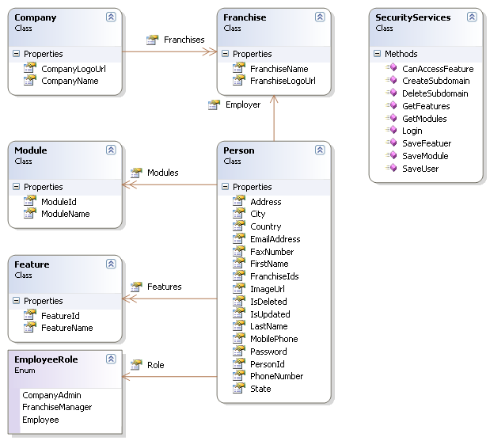

The Company Admin and Franchise Manager are stored in the root system database.
The Individual Employee information is stored only in the Individual Franchise database.

Notification Module:

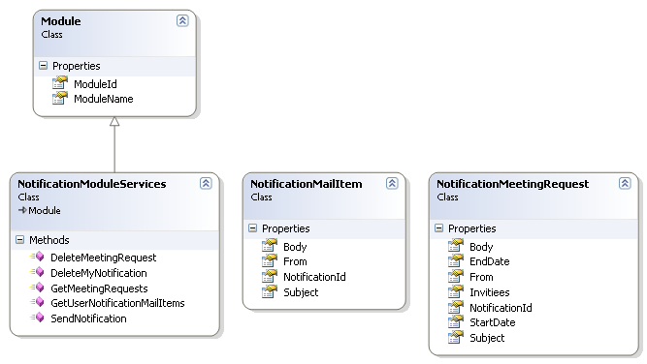

Documents Module:

